BIBLES
The Bible is widely regarded as the greatest book of all times, but there are so many versions in print, which is the right one? Bethel honors Kindergarten, 4th and 8th grade students with age appropriate Bibles designed to be readable and engaging.
* Bethel does not endorse a specific sales site, just these great Bible options. *

Kindergarten – The Beginner’s Bible – an easy to read bible complete with colorful pictures
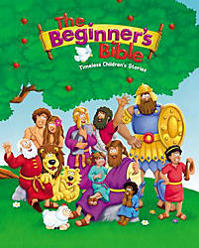

4th Grade – Hands-on Bible – this Bible has complete Biblical text in youth friendly language with engaging activities to help illustrate the meaning of the stories
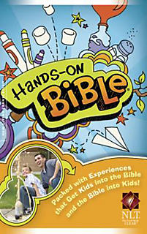

8th Grade - Lutheran Study Bible – this is a complete Bible that also includes Lutheran references that highlight the Lutheran philosophy
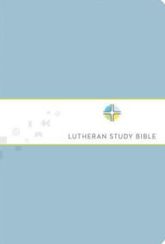

OTHER OPTIONS
If you need something to span those gaps in the Bibles Bethel presents, check out these engaging options.

Sparkhouse Storybook Bible – This Bible includes child friendly language and pictures with more text than the Beginner’s Bible. This is the Bible students reference in Sunday School.
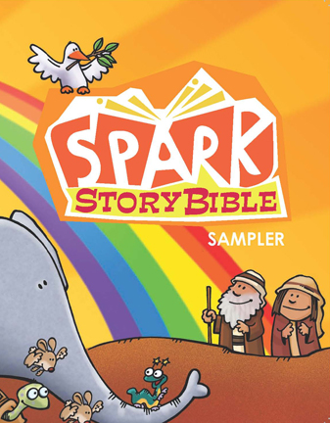

The Action Bible – this is a great option for those readers who love graphic novels
